**Toner Inventory System User Guide**

**Group 1**

**November 27, 2018**

**Team Members**

Khalidah Abdul-Muqtadir

Zachary Muzzleman

Kayla Collazo

James Cooper

# **Contents**

**Contents..............................................................................................................................2**

**1 Introduction.....................................................................................................................3**

**2 Quick Start Guide...........................................................................................................3**

**3 System Requirements......................................................................................................5**

**4 Main Scenarios of Use.....................................................................................................5**

**5 Troubleshooting...............................................................................................................7**

**1 Introduction**

The Toner Inventory System allows users to view and edit stock information for the various printers at multiple campus locations in Delaware Technical Community College. This document will give instructions for using the program to search by printer model/barcode, view stock information and view printer information.

**2 Quick Start**

1. Click the Eclipse Icon on your device. The Eclipse IDE will pop up on your screen.

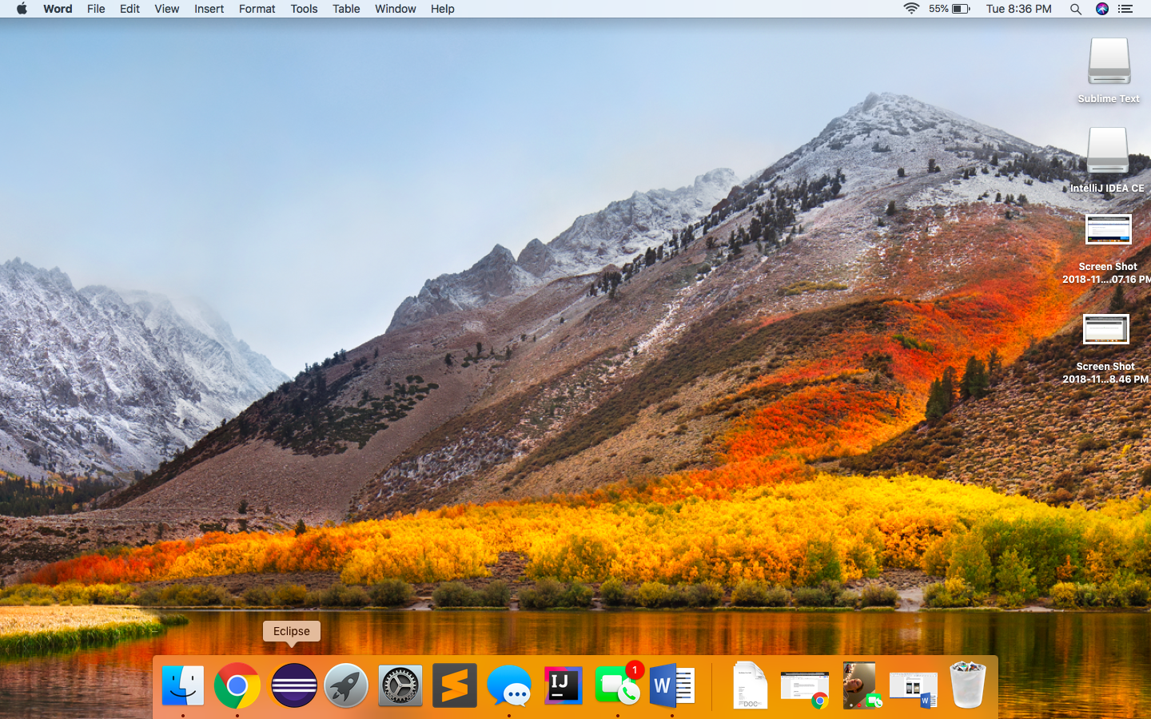

2. Test printer model input by opening the Toner Inventory Project, specifically the TestInventory class in the “src -> default” folder.

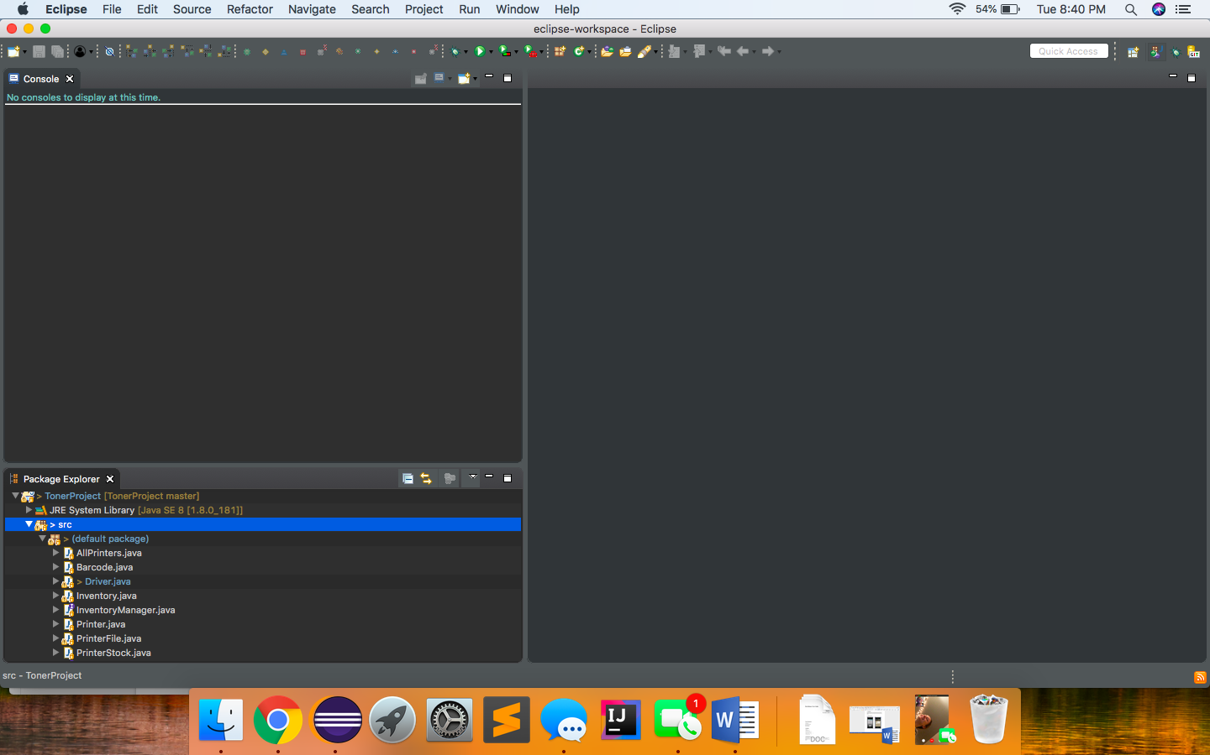

3. Click green “Run” button to run the TestInventory Class.

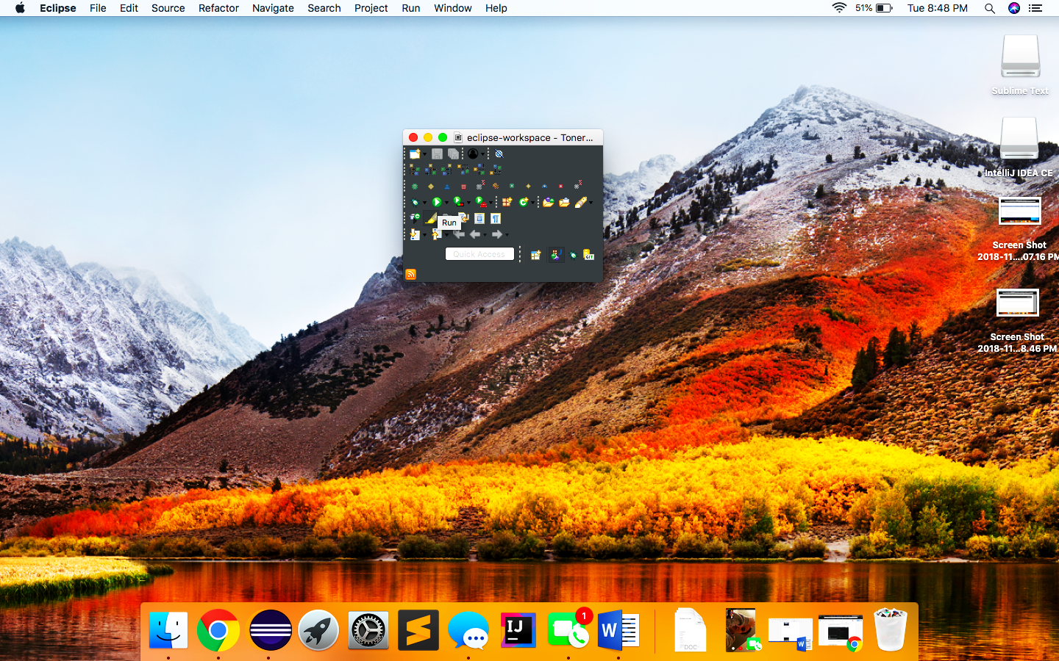

4. When prompted, enter a printer model to display the printer toner information.

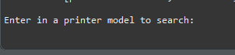

5. Minimum stock, current stock, the amount of toner needed, and if more toner needs to be order will be displayed in a JSON file.

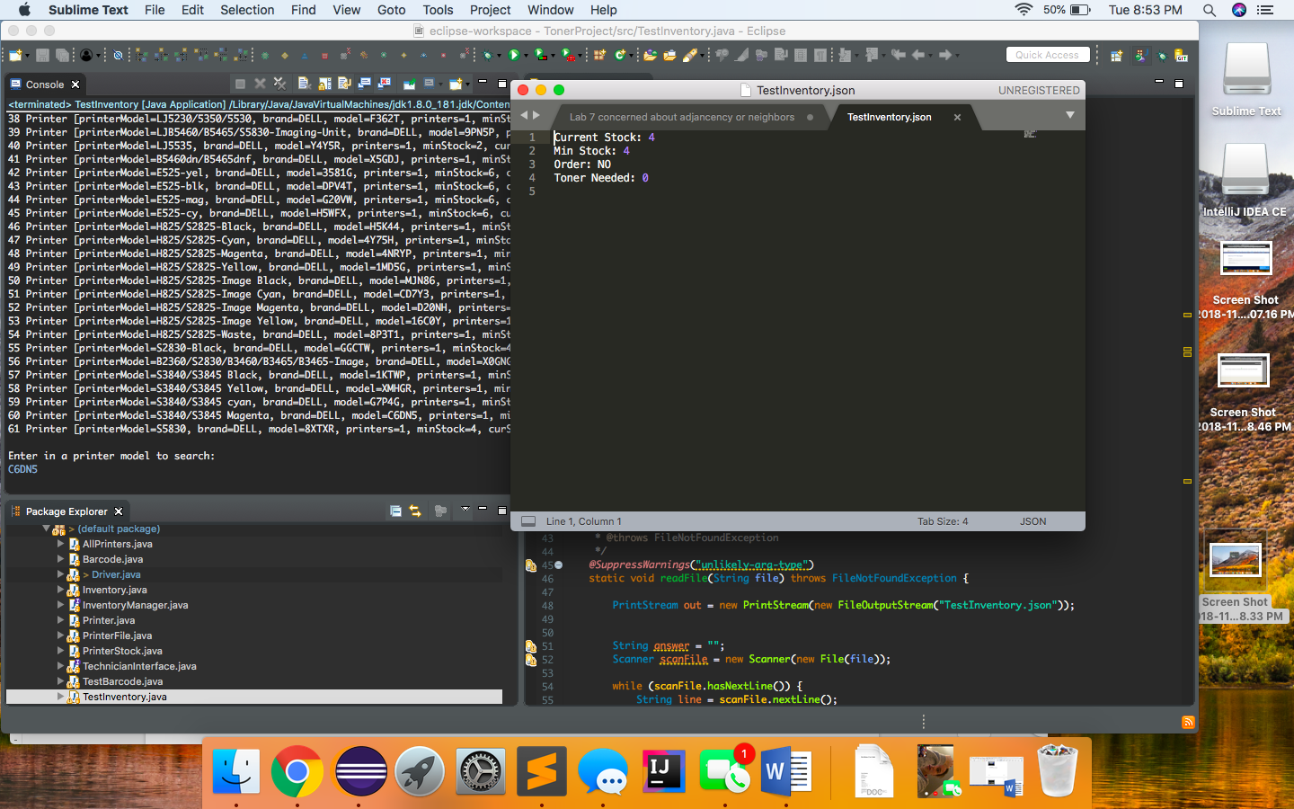

6. To search by Barcode, Click on the TestBarcode class and follow the previous steps for the TestInventory class with barcode input.

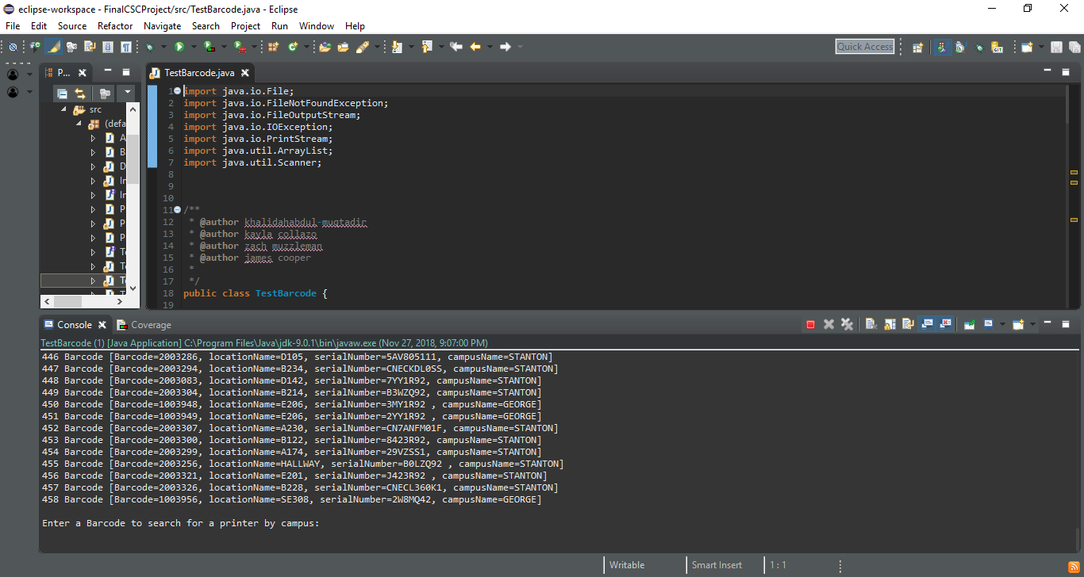

**3 System Requirements**

The Toner Inventory System should be able accessed on an Eclipse-compatible device. Refer to the system documentation for instructions on setup.

**4 Main Scenarios of Use**

***4.1 View/Update Toner Stock Information***

1. Click the Eclipse Icon on your device. The Eclipse IDE will pop up on your screen.
2. Open TonerProject
3. Click on TestInventory class or Barcode Inventory Class
4. Input printer model or printer barcode
5. Display current toner information

***4.2 Update Stock Information***

1. To update stock information, click on “printers.csv” or “WilmingtonTonerDatabase.csv.

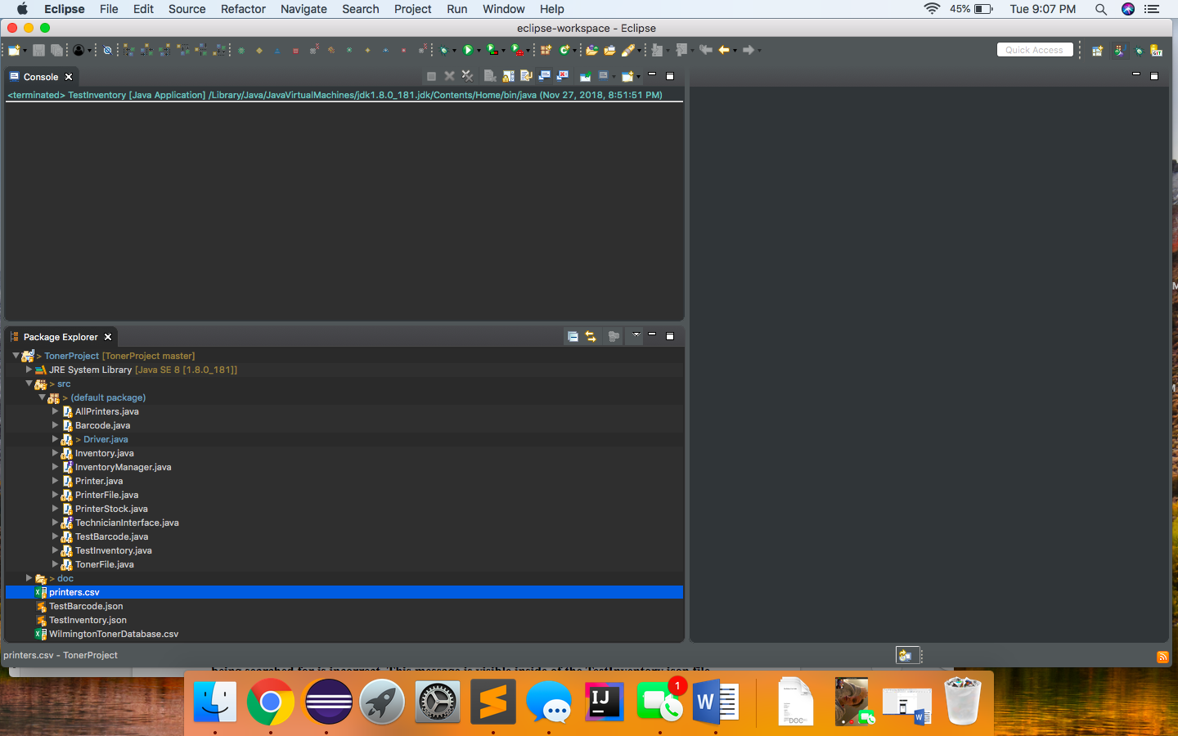 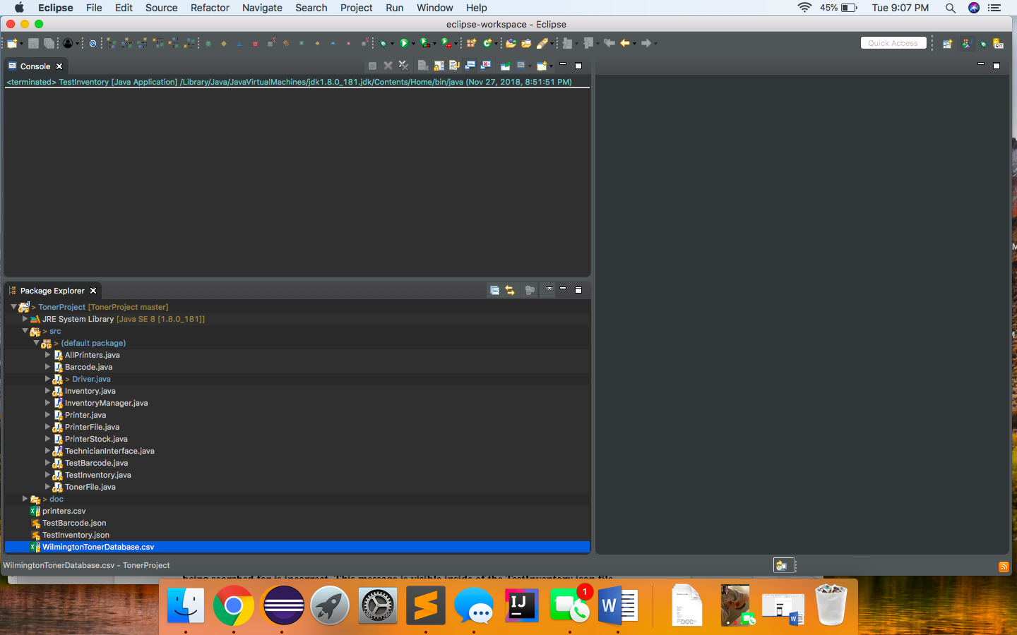

1. Display the excel sheets and edit them with updated toner inventory information as needed.

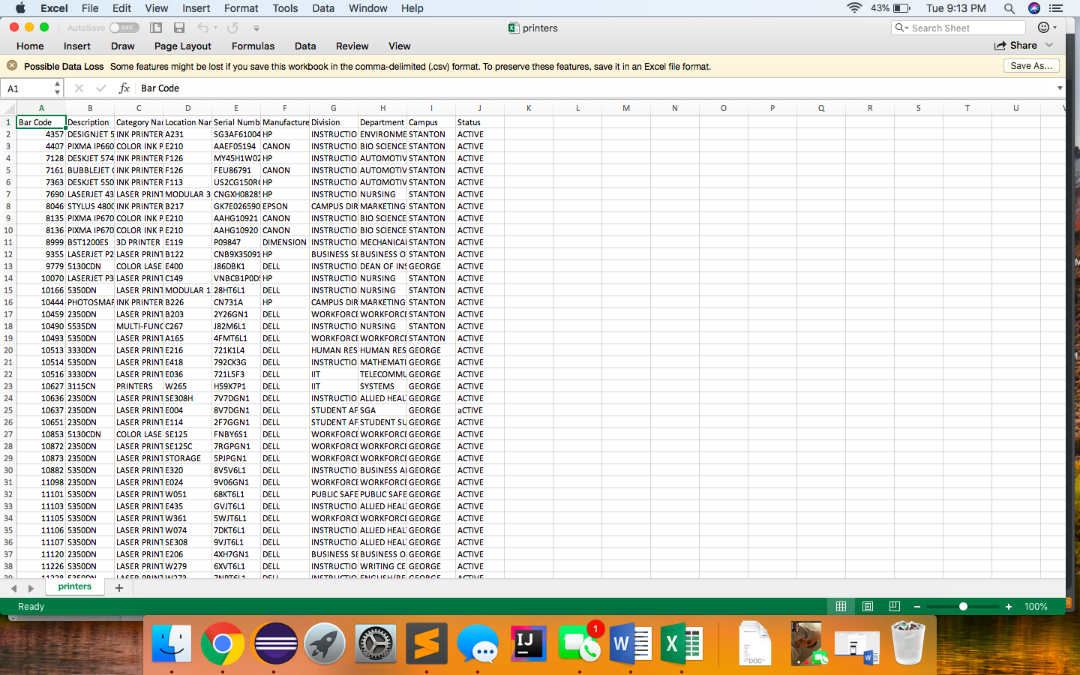 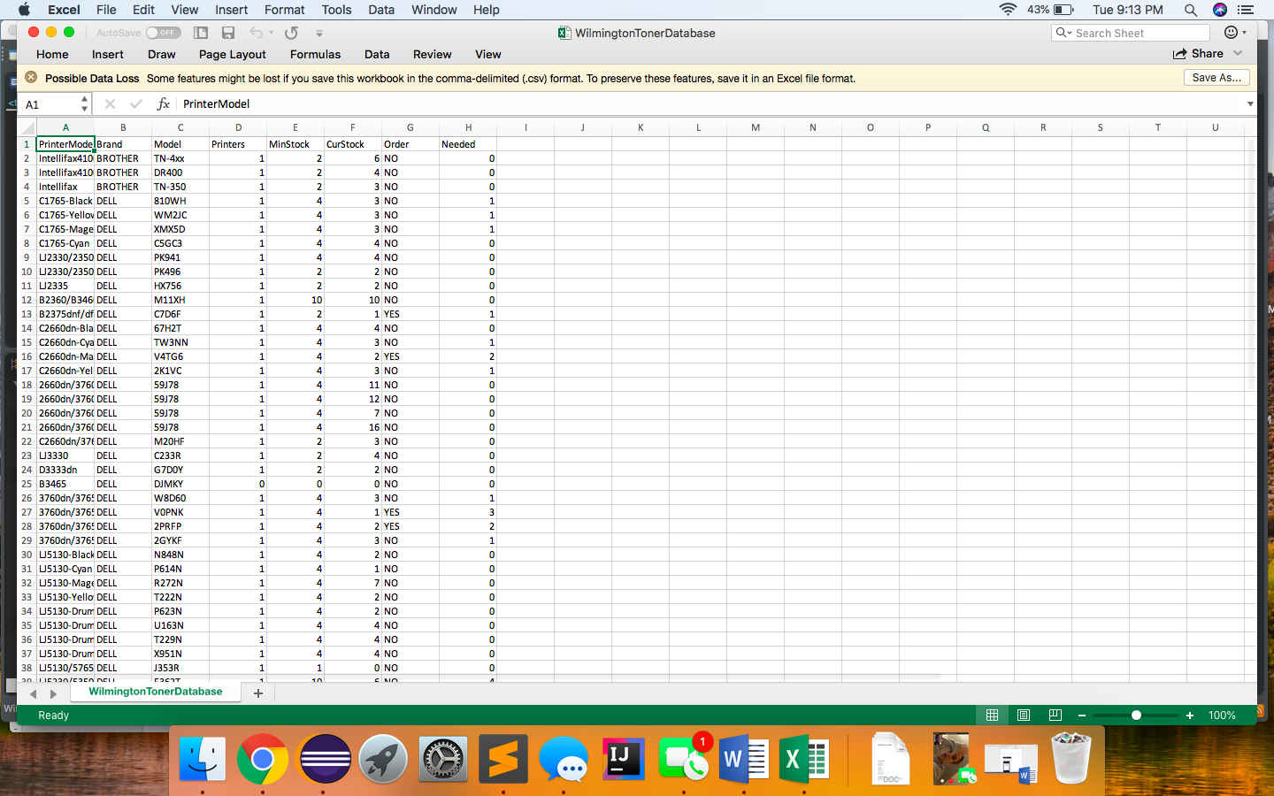

8. Click “File” and “Save” to save updated information.

**5 Troubleshooting**

**5.1 Incorrect Model Number**

**An error message will be displayed to the user in the event that the model number**

**being searched for is incorrect. This message is visible inside of the TestInventory.json file where all of the program output is written. A try again option is then given to the user which allows them to enter in a correct print model number**

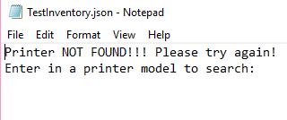

**5.2 Incorrect Barcode**

**An error message will be displayed to the user in the event that the barcode number**

**being searched for is incorrect. This message is visible inside of the TestBarcode.json file where all of the program output is written. A try again option is then given to the user which allows them to enter in a correct print model number**

